**FUNCTIONS**

SARTHAK SANAY

**(1) AIM:-**

To write a program in C to calculate the power of a number using a user-defined function.

**CODE:-**

**#include <math.h>**

**#include <stdio.h>**

**int power(int b, int p)**

**{**

**int pwr= pow(b, p);**

**return pwr;**

**}**

**int main()**

**{**

**int b, p;**

**printf("Enter base: ");**

**scanf("%d", &b);**

**printf("Enter power: ");**

**scanf("%d", &p);**

**int pw= power(b, p);**

**printf("%d raised to the power %d is:- %d",b,p,pw);**

**return 0;**

**}**

**OUTPUT SCREEN:-**

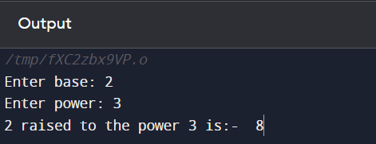

**(2) AIM:-**

To develop a program to check if a number given by the user is prime or not using a function.

**CODE:-**

**#include <stdio.h>**

**int isPrime(int n)**

**{**

**int c=0;**

**for(int i=1; i<=n; i++)**

**{**

**if(n%i==0)**

**c++;**

**}**

**if(c==2)**

**return 1;**

**else**

**return 0;**

**}**

**int main()**

**{**

**int n;**

**printf("Enter a number: ");**

**scanf("%d", &n);**

**if(isPrime(n))**

**printf("%d is a Prime number!", n);**

**else**

**printf("%d is not a Prime number.", n);**

**return 0;**

**}**

**OUTPUT SCREEN:-**

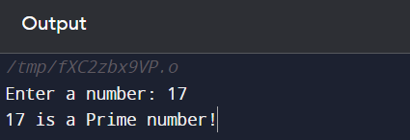 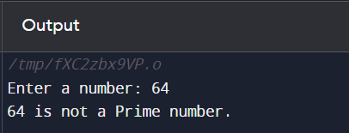

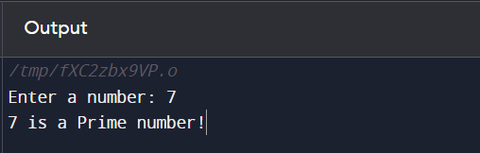 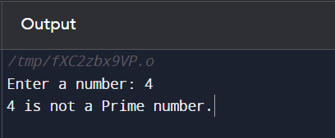

**P.T.O.**

**(3) AIM:-**

To create a function to calculate the factorial of a number.

**CODE:-**

**#include <stdio.h>**

**int fact(int n)**

**{**

**int p=1;**

**for(int i=n; i>=1; i--)**

**{**

**p= p*i;**

**}**

**return p;**

**}**

**int main()**

**{**

**int n, fac;**

**printf("Enter a number: ");**

**scanf("%d", &n);**

**printf("Factorial of %d is %d", n, fact(n));**

**return 0;**

**}**

**OUTPUT SCREEN:-**

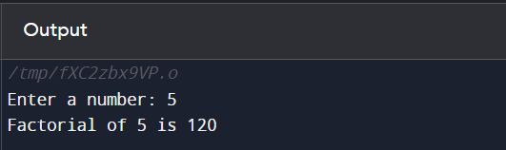

**(4) AIM:-**

To write a function in C to find the maximum of three numbers.

**CODE:-**

**#include <stdio.h>**

**int findMax(int a, int b, int c)**

**{**

**if(a>b && a>c)**

**return a;**

**else if(b>a && b>c)**

**return b;**

**else**

**return c;**

**}**

**int main()**

**{**

**int a, b, c, max;**

**printf("Enter 1st number: ");**

**scanf("%d", &a);**

**printf("Enter 2nd number: ");**

**scanf("%d", &b);**

**printf("Enter 3rd number: ");**

**scanf("%d", &c);**

**max= findMax(a, b, c);**

**printf("The maximum of the three numbers is:- %d", max);**

**return 0;**

**}**

**OUTPUT SCREEN:-**

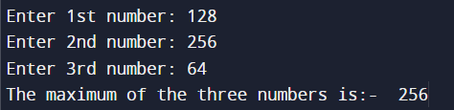

**(5) AIM:-**

To implement recursive functions for finding fibonacci series, factorial of a number, and to print 1 to n.

**CODE 1:- (Fibonacci Series)**

**// Implementing fibonacci series in C using recursive function**

**#include <stdio.h>**

**int fib(int n)**

**{**

**if(n==0)**

**return 0;**

**else if(n==1)**

**return 1;**

**else**

**return fib(n-1) + fib(n-2);**

**}**

**int main()**

**{**

**int n;**

**printf("Enter number of terms: ");**

**scanf("%d", &n);**

**for(int i=0; i<n; i++)**

**{**

**printf("%d\t", fib(i));**

**}**

**return 0;**

**}**

**OUTPUT SCREEN 1:-**

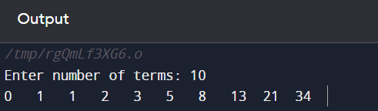

**CODE 2:- (Factorial of a number)**

**// Implementing a program to find the factorial of a number in C using recursive function**

**#include <stdio.h>**

**int fact(int n)**

**{**

**if(n<=1)**

**return 1;**

**else**

**return n*fact(n-1);**

**}**

**int main()**

**{**

**int n;**

**printf("Enter a number: ");**

**scanf("%d", &n);**

**printf("Factorial of %d is %d", n, fact(n));**

**return 0;**

**}**

**OUTPUT SCREEN 2:-**

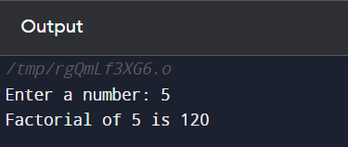

**CODE 3:- (Printing 1 to N using recursion)**

**// Implementing a program in C to print 1 to N using a recursive function**

**#include <stdio.h>**

**int rec(int i, int n)**

**{**

**if(i<=n) // adding a termination condition**

**{**

**printf("%d\n", i);**

**i++;**

**rec(i, n);**

**}**

**}**

**int main()**

**{**

**int n, i=1;**

**printf("Enter the value of n: ");**

**scanf("%d", &n);**

**rec(i, n);**

**return 0;**

**}**

**OUTPUT SCREEN 3:-**

